# Purpose

Items that need to be procured by the Equipment business unit MUST be sourced from TWL where possible.

**What is covered in this guide**

Task 1. Source parts for service calls 2

Task 2. Receipt order (Parts team) 6

Task 3. Process service call part returns to other business units (Parts Team) 7

Task 4. Source parts from a different business unit for a parts sale (Not on a Service Call) 10

Task 5. Processing internal customers (parts team) 12

# Terminology

|  |  |
| --- | --- |
| **SO** | Sales order |
| **TO** | Transfer order |
| **PO** | Purchase order |

# Use of icons

|  |  |  |  |  |  |
| --- | --- | --- | --- | --- | --- |
|  | **Business rule** |  | **Key point / Tips** |  | **Information** |

1. Source parts for service calls

|  |
| --- |
| See **SER_2.1_Parts for Service Calls** for full details on ordering parts for a Service Call |
| Service Team Responsibility  1. For CAT parts:   Select **Service segments > Express picking journal** to order required part(s)  See SER_2.1_Parts for Service Calls  If only CAT parts are required, and these are in stock, no further action is required   1. For other BU parts:   Contact the Parts Team that you want to order parts from, with details of the parts and Service Call / Segment number |
| **Parts Team Responsibility**  CAT parts or a combination of CAT and Other BU parts  These steps are completed by the CAT Parts team in the first instance, then the Other Parts team repeat Steps 3 to 6 below.  Non-CAT parts only on SO  the steps are completed by the Other Parts team/s |
| 1. Navigate to All Sales orders   **GGNZ > Sales and marketing > Common > Sales orders > All sales orders** |
| Do not use My sales orders |
| 1. The **All sales orders** window will display    1. Select Sales orders    2. In Order class filter choose Service from the dropdown list    3. Select OK |
| 1. Remove **Worker-Warehouse filter** |
| 1. Search for the service call number in the Project ID field   The Project ID is required for all Service jobs, it will be supplied to you.  C:\Users\johi\AppData\Local\Temp\SNAGHTML6466de.PNG |
| You can add parts by adding lines to the service sales order.  See **PRT_2.3_Create and Update a Sales Order** for more information |
| Any sales orders matching your search will be displayed   1. Double click on the required Sales order to open it |
| 1. The Sales order window will display |
| Do NOT change the warehouse on the line under any circumstances. If this is changed the parts will not get delivered to the service dept  Transpecs’ Phantom Kits – contact TSL to create these as Production BOMs instead (as required) |
| 1. Complete a Backorder review in the normal manner |
| See **PRT_3.4_Source Parts through Backorder** |
| If items don’t appear on the backorder review, create a manual Transfer Order or Purchase Order as required   * For Transfer Order see **PRT_3.2_Create and Manage a Transfer Order** * For Purchase Order, **SLS_2.1_Create Purchase Order from Sales Order** * Set the Ship Instructions to Direct Ship Transfer |
| 1. If using a manually created order, go back to the Sales Order |
| 1. Select each Sales line in turn    1. Select Inventory    2. Select Marking   This links the SO to the TO or PO to allow the correct processing |
| Find the Purchase or Transfer Order   1. Tick the **Set mark now** box |
| 1. Select **OK** |

1. Receipt order (Parts team)

|  |
| --- |
| Follow SOP **PRT_5.3_Receive Parts into Stock** to receipt parts  Make sure the Print SO Packing slip box is checked. This will provide the SO Packing Slip for staff to send with the goods to the Service Dept. The marking provided earlier for manual orders also allows this to happen |
| No freight is to be charged on the Sales Order |

1. Process service call part returns to other business units (Parts Team)

|  |
| --- |
| 1. Only accept returned parts if accompanied with the form    1. Service staff should return parts with the form    2. Form shows Segment number (project ID) to find the related Sales order    3. The part details will already be entered on the Sales Order    4. Returned items will show as a negative quantity |
| 1. Expand Sales order lines fast tab    1. Select Update line    2. Select Registration |
| No restocking fee to be applied  For cash Service Call credits, items must be credited into the warehouse on the Service Call, then transferred manually via a Transfer Order to the Other BU. |
| 1. Complete the registration    1. Tick **Auto-create**    2. Change the **Warehouse** to own warehouse if it is incorrect    3. Select **Post All**    4. Select **Close** |
| 1. Repeat return process for each line being returned see Task 2, **Service team responsibility**, |
| The Sales order screen displays   1. Select **Pick and pack > Delivery note** |
| 1. On the Delivery note posting, select the Lines tab and check the Update quantity |
| The quantity will be a negative number |
| 1. Set up delivery note printing    1. Tick the box by Posting    2. The Print delivery note can be ticked but is optional    3. Select **OK** |

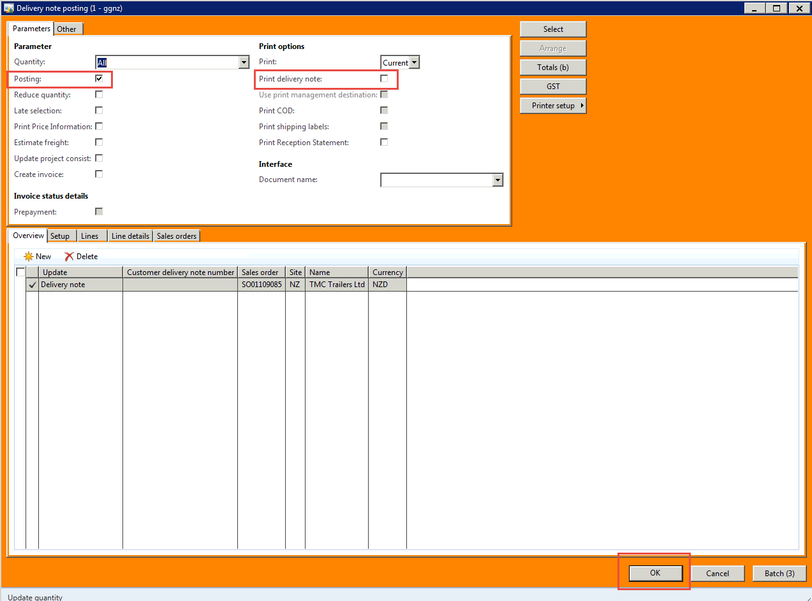

1. Source parts from a different business unit for a parts sale (Not on a Service Call)

|  |
| --- |
| Items that need to be procured by a business unit MUST be sourced from within the NZ Gough Group where possible. |
| 1. Navigate to All sales orders   **GGNZ > Sales and marketing > Common > Sales orders > All sales orders** |
| The **All sales orders** window will display   1. From the Sales orders tab    1. Select Order class filter    2. Select appropriate Order Class for processing from the dropdown list:       * CAT Parts select **PARTEQUIP**       * TWL select **PARTNZT**       * Transpecs select **PARTTSL**       * Palfinger Parts select **PARTPALNZ**       * Industrial Solutions select **ENG PRD**       * GMH Parts select **PARTGMH**    3. C:\Users\johi\AppData\Local\Temp\SNAGHTML16ec2c9.PNGSelect OK |
| **Or**   1. Go to All Sales Orders 2. Change the Order Class as below 3. Remove the Worker/Warehouse filter |
| 1. Add parts to the Sales Order as required |
| Under no circumstances change the warehouse on the line |
| If backorder required, complete the Backorder review in the normal manner.  For more information, see SOP **PRT_3.4_Source Parts through Backorder** |

1. 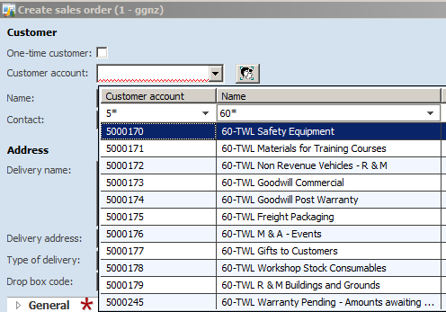Processing internal customers (parts team)

|  |
| --- |
| This is for inter-business unit transactions that previously required Purchase Orders or the use of P-Cards for consumables |
| 1. Create a new Sales Order, see **PRT_2.3_Create and Update A Sales Order** |
| Instead of adding an external customer use these steps to use an internal customer |
| 1. Add an internal customer on the sales order    1. Enter internal customer account details if necessary filter to find internal customer. Internal Customer accounts begin with ‘5’,   The **Customer Name** will contain the Warehouse number applicable. |
| 1. Populate the following fields on the **General and Administration** fast tabs    1. **Customer reference** Record information that can be used to identify the purpose of the internal consumption e.g. Truck Show Prize    2. **Sales Responsible** should contain the user that is requesting the items. This will be used for Reporting purposes. |
| 1. If one of the following Internal accounts have been used complete step 31  * EEQ New Equipment inventory Cust Acct 5000281 * EEQ Used Equipment inventory Cust Acct 5000282   If you do not populate the Equipment ID, you will not be able to invoice the Sales order |
| 1. Enter the **Equipment ID** in the Equipment field   The Serial number, Model and Make will auto-populate  The Equipment ID will be provided to you by the person ordering the parts |